Comparative Time Series Forecasting of Oil Prices
Name: Thulluri Ramya Student ID: 23097466
Github Link: https:/github.com/thulluri-ramya/Comparative-Time-Series-Forecasting-of-Oil-Prices
Tutor: William Alston

- Introduction :
Oil prices are an important factor in the global economy because they affect transportation costs, energy production, and overall economic activity. As a result, the ability to accurately predict oil price movements is valuable for governments, investors, and businesses when making strategic and financial decisions. However, forecasting oil prices is a challenging task because they are influenced by many uncertain factors such as geopolitical events, supply and demand changes, and fluctuations in global markets.
Time series forecasting methods are widely used to analyse historical data and predict future values. Traditional statistical approaches, including Autoregressive Moving Average (ARMA) and Autoregressive Integrated Moving Average (ARIMA) models, are commonly applied to time series data. These models focus on identifying patterns and relationships within past observations and are particularly useful when the data is stationary.
More recently, machine learning and deep learning techniques have been increasingly used for forecasting problems. Among these methods, Long Short-Term Memory (LSTM) networks have shown strong performance when working with sequential data. LSTM models are capable of learning complex patterns and long-term relationships in time series data, which makes them suitable for modelling financial and economic variables.
The objective of this study is to examine and forecast oil price trends using both statistical and deep learning techniques. In particular, an ARIMA model and an LSTM neural network are developed and applied to the oil price dataset. The performance of these models is evaluated using standard forecasting error metrics, and both models are used to generate predictions for the next 24 months. The results are then compared to understand the strengths and limitations of each modelling approach.

- Data Description and Pre-Processing:
The dataset used in this analysis contains historical observations of oil prices measured in US dollars over time. Each observation corresponds to a specific date and the associated price of oil on that date. Because the data is structured chronologically, it is suitable for time series analysis and forecasting.
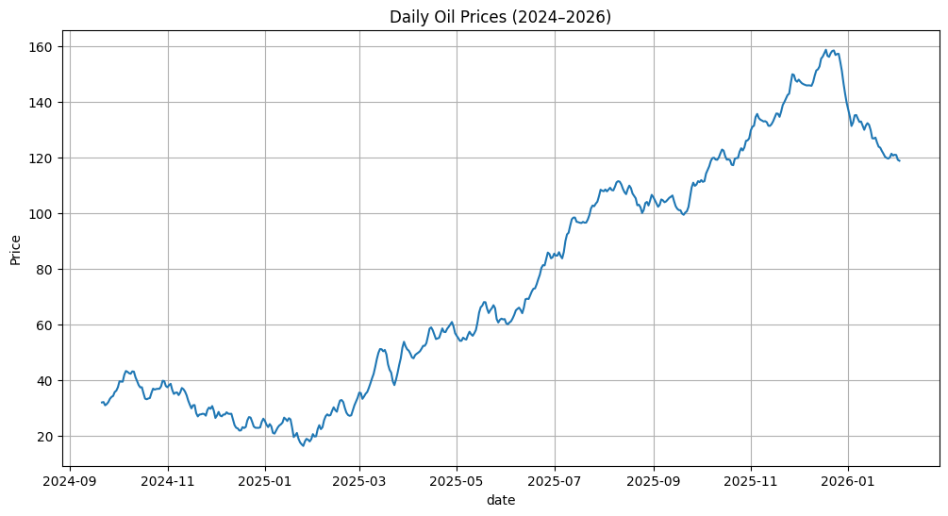
Figure 1: Historical oil price time series used for modelling.
Before building the forecasting models, several preprocessing steps were performed to prepare the dataset. First, the date column was converted into a datetime format and set as the index of the dataset. This step is important because it allows the data to be handled correctly as a time series. A visual inspection of the oil price series was then conducted by plotting the values over time. This helped identify overall patterns such as trends, fluctuations, and periods of high volatility. Basic descriptive statistics were also calculated to better understand the characteristics of the dataset. These statistics include the mean, standard deviation, minimum value, and maximum value of the oil prices. Such summary measures provide insight into the distribution and variability of the data.
Table 1: Summary Statistics
count 500.000000 | mean 75.873980
std 42.912398 | min 16.480000
25% 35.372500 | 50% 64.290000
75% 111.572500 | max 158.780000
For the LSTM model, an additional preprocessing step was required. Neural network models generally perform better when the input values are scaled to a similar range. Therefore, the oil price values were normalised using a MinMaxScaler, which transformed the data to a range between 0 and 1. This scaling improves the stability and efficiency of the model during the training process.
- Stationarity Analysis:
Stationarity is an important requirement for many traditional time series models, including ARIMA. A stationary time series has constant statistical properties over time, such as a stable mean and variance. If a time series is non-stationary, the results of the model may become unreliable.
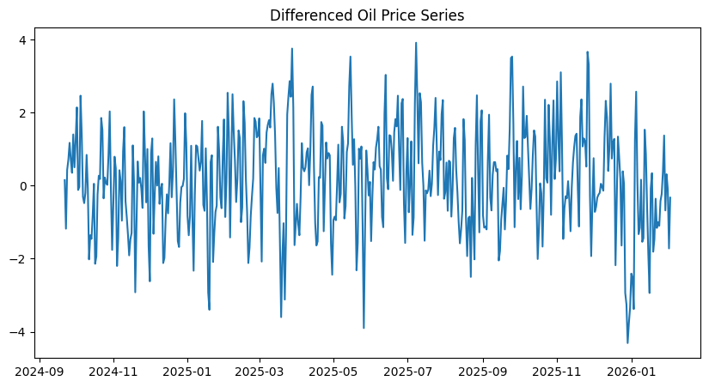
Figure 2: Differenced oil price series used to achieve stationarity.
To determine whether the oil price data was stationary, the Augmented Dickey–Fuller (ADF) test was applied. The null hypothesis of the ADF test assumes that the time series contains a unit root, meaning that it is non-stationary. If the resulting p-value is greater than 0.05, the null hypothesis cannot be rejected and the data is considered non-stationary.
The results of the ADF test indicated that the original oil price series was not stationary. This outcome is common for financial time series, as they often contain trends and changing levels over time. To address this issue, first-order differencing was applied to the data. Differencing works by subtracting the previous observation from the current one, which helps remove the trend and stabilise the series.
After applying differencing, the stationarity of the data was examined again. The transformed series showed more stable behaviour and was suitable for modelling using the ARIMA approach. In addition, the Autocorrelation Function (ACF) and Partial Autocorrelation Function (PACF) plots were generated to assist in determining appropriate model parameters.
- Arima Model:
The ARIMA model is a widely used statistical technique for analysing and forecasting time series data. The model combines three components: autoregressive (AR), differencing (I), and moving average (MA). The autoregressive part captures the relationship between an observation and its previous values, while the moving average component accounts for the relationship between an observation and past prediction errors. The differencing component is used to make the series stationary when necessary.
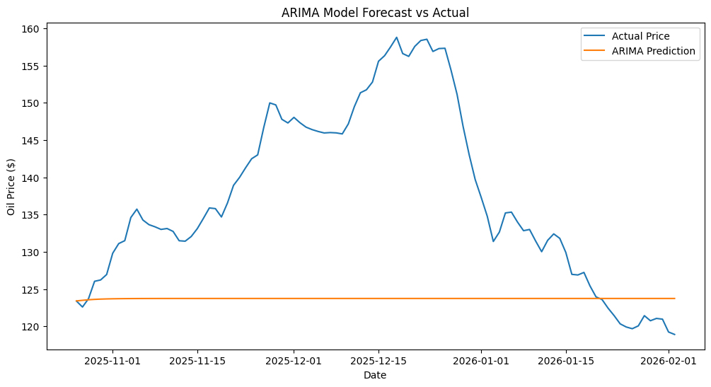
Figure 3: ARIMA predictions compared with actual oil prices.
In this study, the ARIMA model was applied to the oil price dataset after confirming the stationarity of the differenced series. The ACF and PACF plots were examined to identify appropriate values for the autoregressive and moving average parameters. Based on this analysis, a suitable combination of parameters was selected for the model.
To determine the most suitable ARIMA configuration, a grid search approach was used to test different parameter combinations. The parameters p, d, and q represent the autoregressive order, differencing order, and moving average order respectively. In this study, the parameter space was explored using p values from 0 to 8, d values from 0 to 2, and q values from 0 to 8. For each combination, the Akaike Information Criterion (AIC) was calculated. The model with the lowest AIC value was selected as the optimal configuration, as a lower AIC indicates a better balance between model fit and complexity.
The dataset was divided into training and testing portions to evaluate the forecasting performance. The model was trained using the training data and then used to generate predictions for the test data. These predictions were compared with the actual observed oil prices to assess the accuracy of the model.

Table 2: ARIMA Evaluation Metrics
MAE | 14.572486526233384
RMSE | 18.047123733676408
Two evaluation metrics were used to measure model performance: Mean Absolute Error (MAE) and Root Mean Squared Error (RMSE). These metrics provide an indication of the average difference between the predicted values and the actual observations. Lower values of these metrics indicate better forecasting accuracy.
The trained ARIMA model was also used to generate forecasts for the next 24 months. Confidence intervals were included to represent the uncertainty associated with these future predictions.
Residual Analysis:
After fitting the ARIMA model, residual diagnostics were performed to assess whether the model had adequately captured the structure of the data. Ideally, the residuals should behave like white noise, meaning that they should have no significant autocorrelation and should follow a roughly normal distribution.
An autocorrelation function (ACF) plot of the residuals was generated to check for remaining correlations in the model errors. The absence of significant spikes in the residual ACF indicates that the model has successfully captured most of the temporal structure of the series. In addition, the distribution of the residuals was inspected using a histogram to verify whether the errors were approximately normally distributed.

- LSTM Model:
In addition to the statistical ARIMA model, a Long Short-Term Memory (LSTM) neural network was implemented to forecast oil prices. LSTM networks are a type of recurrent neural network that are specifically designed to process sequential data. Unlike traditional neural networks, LSTM models are able to retain information from previous time steps, allowing them to capture long-term dependencies in time series data.
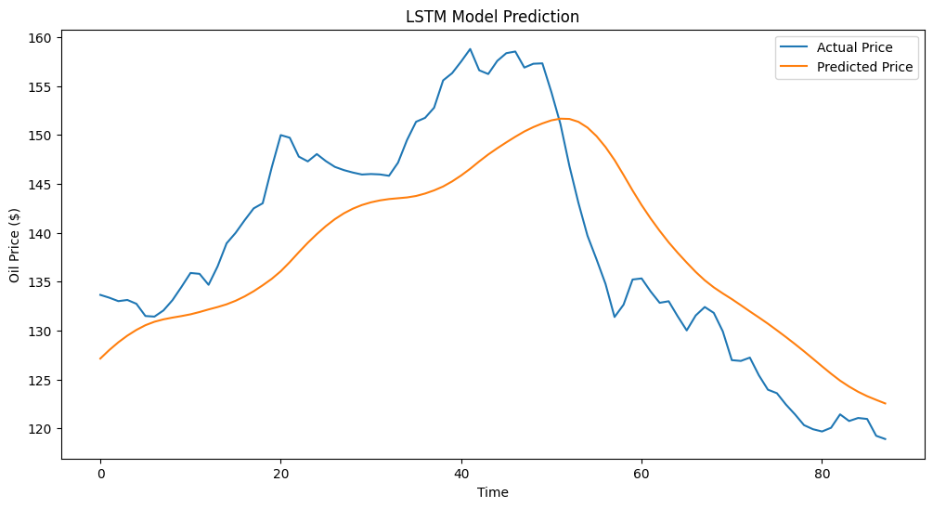
Figure 4: LSTM model predictions compared with actual values.
Before training the LSTM model, the oil price values were scaled using a MinMaxScaler to normalise the data between 0 and 1. A sliding window approach was then used to create input sequences for the model. In this approach, a fixed number of previous observations (referred to as the window size) were used to predict the next value in the sequence.
The LSTM architecture used in this study consisted of two LSTM layers followed by a dense output layer. The model was trained using the Adam optimisation algorithm with mean squared error as the loss function. During training, the model learned patterns and relationships within the historical oil price data.
After the training process was completed, the model was used to generate predictions for the test dataset. The predicted values were then converted back to the original scale and compared with the actual oil prices. Similar to the ARIMA model, MAE and RMSE were used to evaluate the performance of the LSTM model.
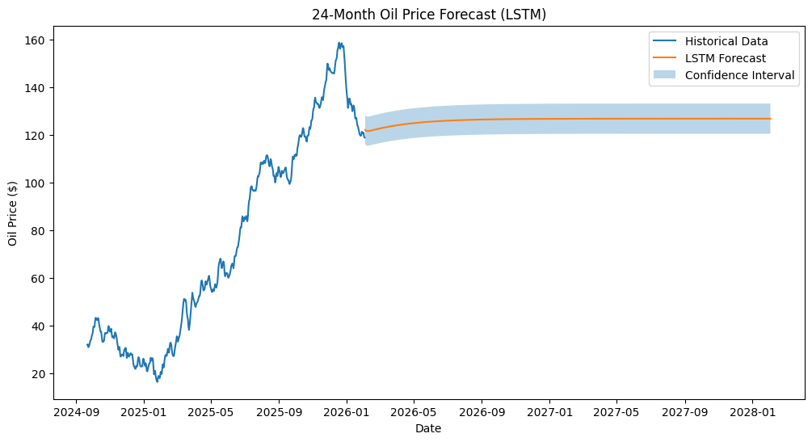
Figure 5: 24-month oil price forecast generated using the LSTM model.
Finally, the trained LSTM model was used to forecast oil prices for the next 24 months, allowing for a comparison between the statistical and deep learning approaches.
- Results and Model Comparison:
After implementing both the ARIMA and LSTM models, their forecasting performance was evaluated using standard error metrics. The models were tested using the test portion of the dataset, and their predictions were compared with the actual observed oil prices.
Table 3: comparison table from both model Results.
Model | MAE | RMSE
ARIMA | 14.57 | 18.05
LSTM | 6.41 | 7.23

To measure the accuracy of the forecasts, two evaluation metrics were used: Mean Absolute Error (MAE) and Root Mean Squared Error (RMSE). MAE calculates the average absolute difference between predicted and actual values, while RMSE gives more weight to larger errors and provides an indication of the overall forecasting accuracy.
From the results, it can be observed that the LSTM model achieved lower error values compared to the ARIMA model. This indicates that the LSTM model was more effective in capturing the patterns within the oil price time series. The improved performance of the LSTM model may be attributed to its ability to learn complex and nonlinear relationships in sequential data.
In addition to numerical evaluation, the forecasting performance was also assessed visually by comparing the predicted values with the actual observations. The ARIMA model was able to capture the overall trend of the oil price series but sometimes struggled to follow sudden fluctuations. In contrast, the LSTM model produced predictions that more closely followed the variations in the data.
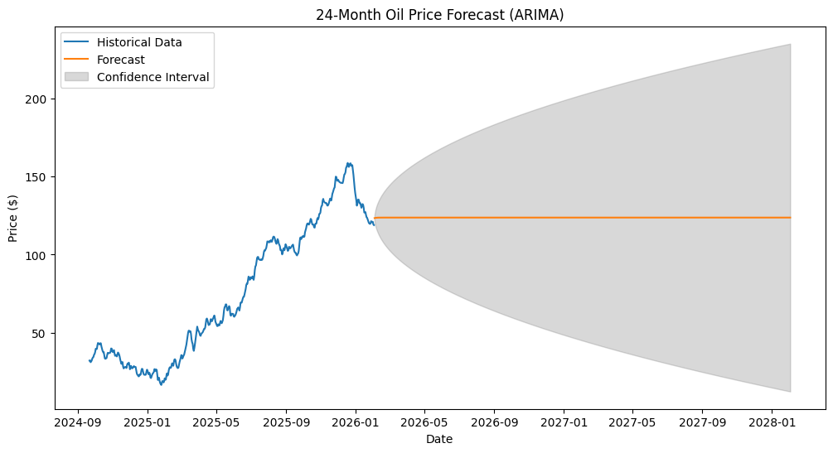
Figure 6: 24-month oil price forecast generated using the ARIMA model.
Both models were also used to generate forecasts for the next 24 months. The ARIMA forecast included confidence intervals, which illustrate the uncertainty associated with long-term predictions. As expected, the width of the confidence intervals increased over time, reflecting the growing uncertainty in forecasting further into the future.
When comparing the predicted values with the actual oil prices in the testing dataset, it was observed that the LSTM model followed the fluctuations in the series more closely than the ARIMA model. While the ARIMA model was able to capture the general trend of the time series, it struggled to react quickly to sudden changes in oil prices. In contrast, the LSTM model was better able to adapt to short-term variations, resulting in lower forecasting errors.
- Discussion and Critical Analysis:
Although both the ARIMA and LSTM models were able to generate reasonable forecasts, their performance differed due to the nature of their modelling approaches.
The ARIMA model is based on linear relationships within the time series data. While it performs well when patterns are stable and the data is stationary, it may struggle to capture complex nonlinear behaviour. Oil prices are influenced by many unpredictable factors, such as geopolitical events, global demand changes, and economic policies. Because ARIMA relies primarily on historical patterns, it may not fully capture these dynamic influences.
On the other hand, the LSTM model is capable of learning nonlinear relationships and long-term dependencies within the data. This allows the model to adapt more effectively to the fluctuations commonly observed in financial time series. The improved accuracy of the LSTM model in this study suggests that deep learning approaches may be more suitable for modelling complex economic variables such as oil prices.
Another important observation from the forecasts is the increase in uncertainty as the forecast horizon becomes longer. This is reflected in the widening confidence intervals in the ARIMA forecasts. Such behaviour is expected in time series forecasting because prediction errors accumulate over time.
Despite the advantages of the models us ed in this study, several limitations should be acknowledged. The analysis was based solely on historical oil price data without incorporating additional variables that may influence price movements. Factors such as global economic conditions, supply disruptions, and geopolitical conflicts can significantly impact oil markets. Including such external variables could potentially improve forecasting performance.
- Future Work and Improvements:
There are several ways in which this analysis could be improved in future work. One possible improvement would be to incorporate additional explanatory variables that influence oil prices, such as global oil demand, inflation rates, or economic growth indicators. Including these variables could help capture broader economic dynamics that affect oil price movements.
Another potential improvement would be to experiment with more advanced deep learning architectures. Models such as Gated Recurrent Units (GRU) or transformer-based time series models have shown promising results in recent forecasting studies and may provide improved predictive performance.
Furthermore, ensemble approaches that combine predictions from multiple models could be explored. By integrating the strengths of different modelling techniques, ensemble methods often produce more robust and accurate forecasts.
- Conclusion:
This study examined the forecasting of oil prices using both statistical and deep learning approaches. Two models were implemented: the ARIMA model and the Long Short-Term Memory (LSTM) neural network.
The results showed that both models were capable of capturing the general trend of the oil price time series. However, the LSTM model demonstrated better forecasting performance in terms of error metrics and its ability to follow fluctuations in the data. This highlights the potential advantages of deep learning models when dealing with complex and nonlinear time series data.
Overall, the findings suggest that combining traditional statistical methods with modern machine learning techniques can provide valuable insights for time series forecasting. While no model can perfectly predict oil price movements, these approaches can help improve forecasting accuracy and support better decision-making.
Although the LSTM model achieved better predictive accuracy in this study, statistical models such as ARIMA remain valuable due to their interpretability and lower computational cost.
- References:
      - Hochreiter, S. and Schmidhuber, J., 1997. Long short-term memory. Neural Computation, 9(8), pp.1735–1780.
      - Box, G.E.P., Jenkins, G.M., Reinsel, G.C. and Ljung, G.M., 2015. Time series analysis: forecasting and control. 5th ed. Hoboken, NJ: Wiley.
      - Taylor, S.J. and Letham, B., 2018. Forecasting at scale. The American Statistician, 72(1), pp.37–45.
      - Zhang, G., 2003. Time series forecasting using a hybrid ARIMA and neural network model. Neurocomputing, 50, pp.159–175.

